**Banking Application of organizations and individuals.**



**Session 2024 - 2028**

**Submitted by:**

Hussain Shahbaz 2024-CS-04

**Supervised by:**

Dr. Muhammad Awais Hassan

**Course:**

CSC-102 Programming Fundamentals

Department of Computer Science

**University of Engineering and Technology**

**Lahore Pakistan**

* **Short Description of your project**
  + In the banks, you have to wait so much for your query to be listened, and in order for it to be done even takes more time. I want to save the time of both the bankers and the civilians to store their money. This app will let to user to apply for loans, apply for the availability of lockers to store their important stuff, transact and receive money to some other account at the comfort of his phone. My bank application project will contribute to the field of computer science by demonstrating he application of key software engineering principles, such as modular design and scalability, which are essential for building maintainable systems. By integrating advanced security features like encryption, secure authentication, and data protection, it highlights the importance of cybersecurity in real-world financial applications.
* **Users of Application**

This app will be used by individuals, organizations, admins, students, companies finance managers, and bank managers. Some common examples of project users include:

* **Individual Customers**: Perform daily banking tasks such as checking balances, transferring funds, applying for loans, and using lockers.
* **Organizations**: Manage employee salary payments and track financial records automatically.
* **Finance Managers**: Oversee salary distribution, manage organization finances, and ensure accurate financial tracking.
* **Bank Managers/Admins**: Supervise system operations, approve loan and locker applications, and ensure system security.

**Functional Requirements:**

|  |  |  |  |
| --- | --- | --- | --- |
| User Story ID | *As a* | *I want to perform* | *So that I can* |
| 1 | *User* | *Transact money, send money, receive money* | *Ease the money transactions* |
| **2** | Admin | Calculate the Price. | Create of delete account, check the account’s activity |
| **3** | User | Apply for loans, lockers | Easily apply through the app at the comfort of my own house |
| **4** | Admin | Approve loan and locker applications | Let the user check the status of his application |
| **5** | Organizations | Automate salary distribution to employees | Ensure timely payments and maintain accurate salary records |
| **6** | Admin | Monitor suspicious transactions and flag them for review | Prevent fraud and maintain the integrity of the banking system. |
| **7** | User | Access a transaction history of all my banking activities | Keep track of my expenses and payments |
| **8** | Employee | Apply for bonuses or request pretimed salary | Ease the process of advance salary |
| **9** | Organization | Approve advance salary | Ease the process of employee salary |
| **10** | Organizations | Trak employee tax deductions and other benefits | Ensure proper payroll management and regulatory compliance |

And much more..

* **Wireframes**

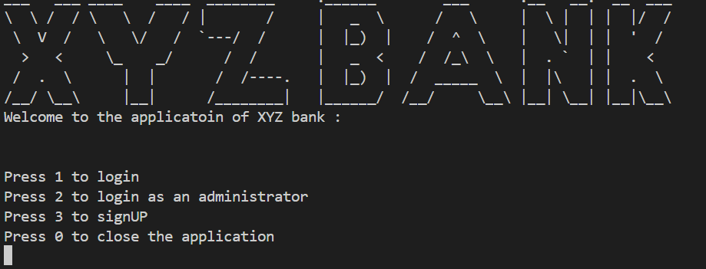

Figure : Bank interface

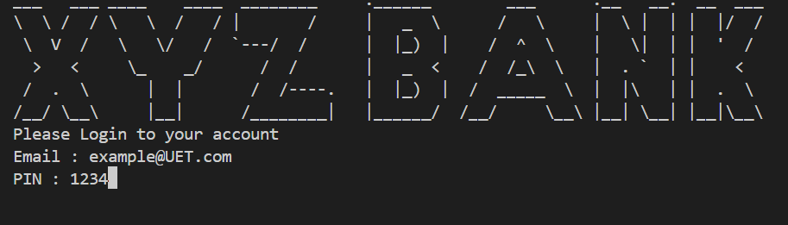

Figure : User Login Page

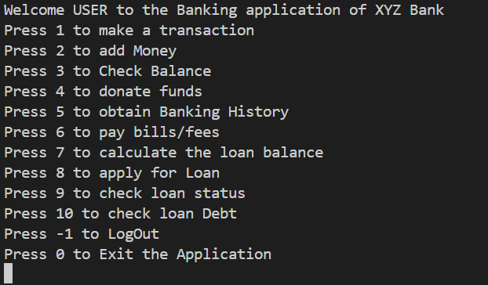

Figure : User Functional interface

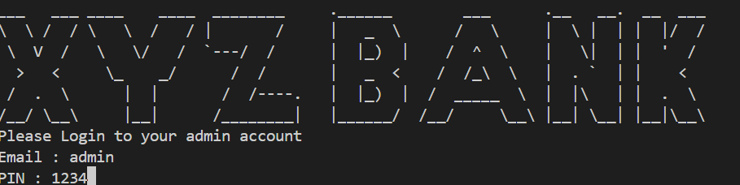

Figure : Admin login interface

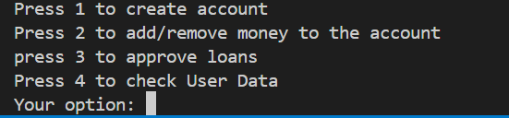

Figure : Admin functional interface

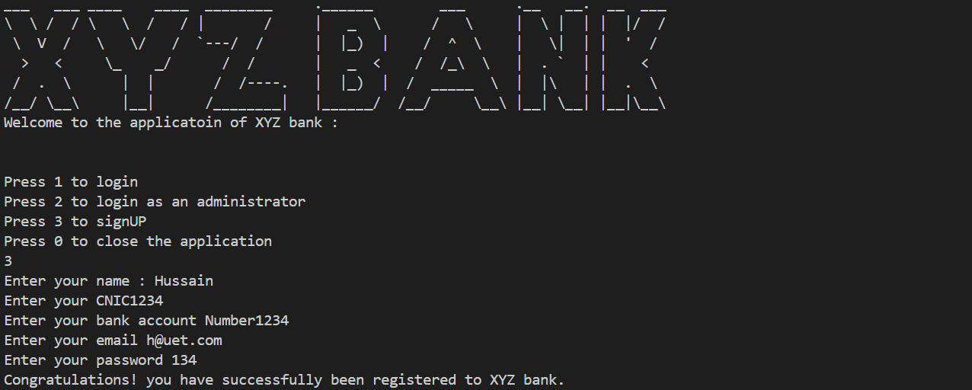

Figure : Signup interface